- Go to www.mysolidworks.com and click join in the top right.
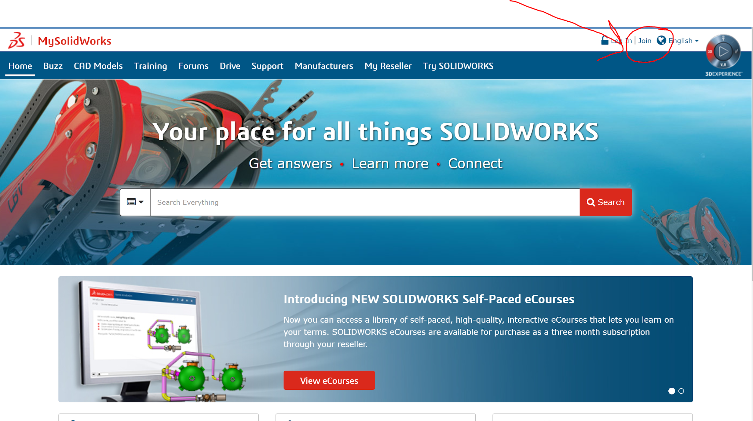
- Follow the instructions below and fill out all required fields.
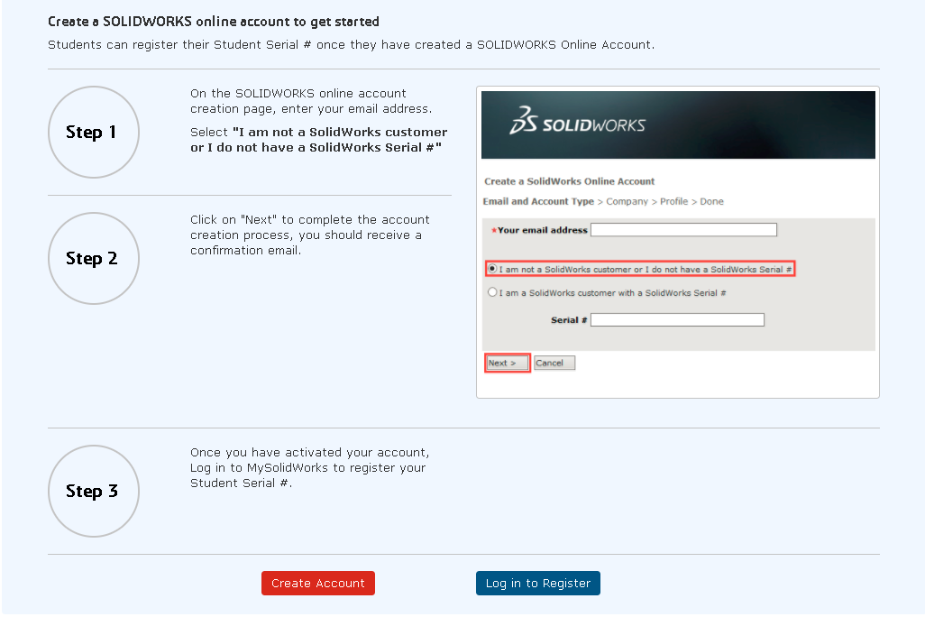
- Once the email is confirmed, you can log in. Once logged in, click the drop down under their name in the top right and click “my subscriptions”.
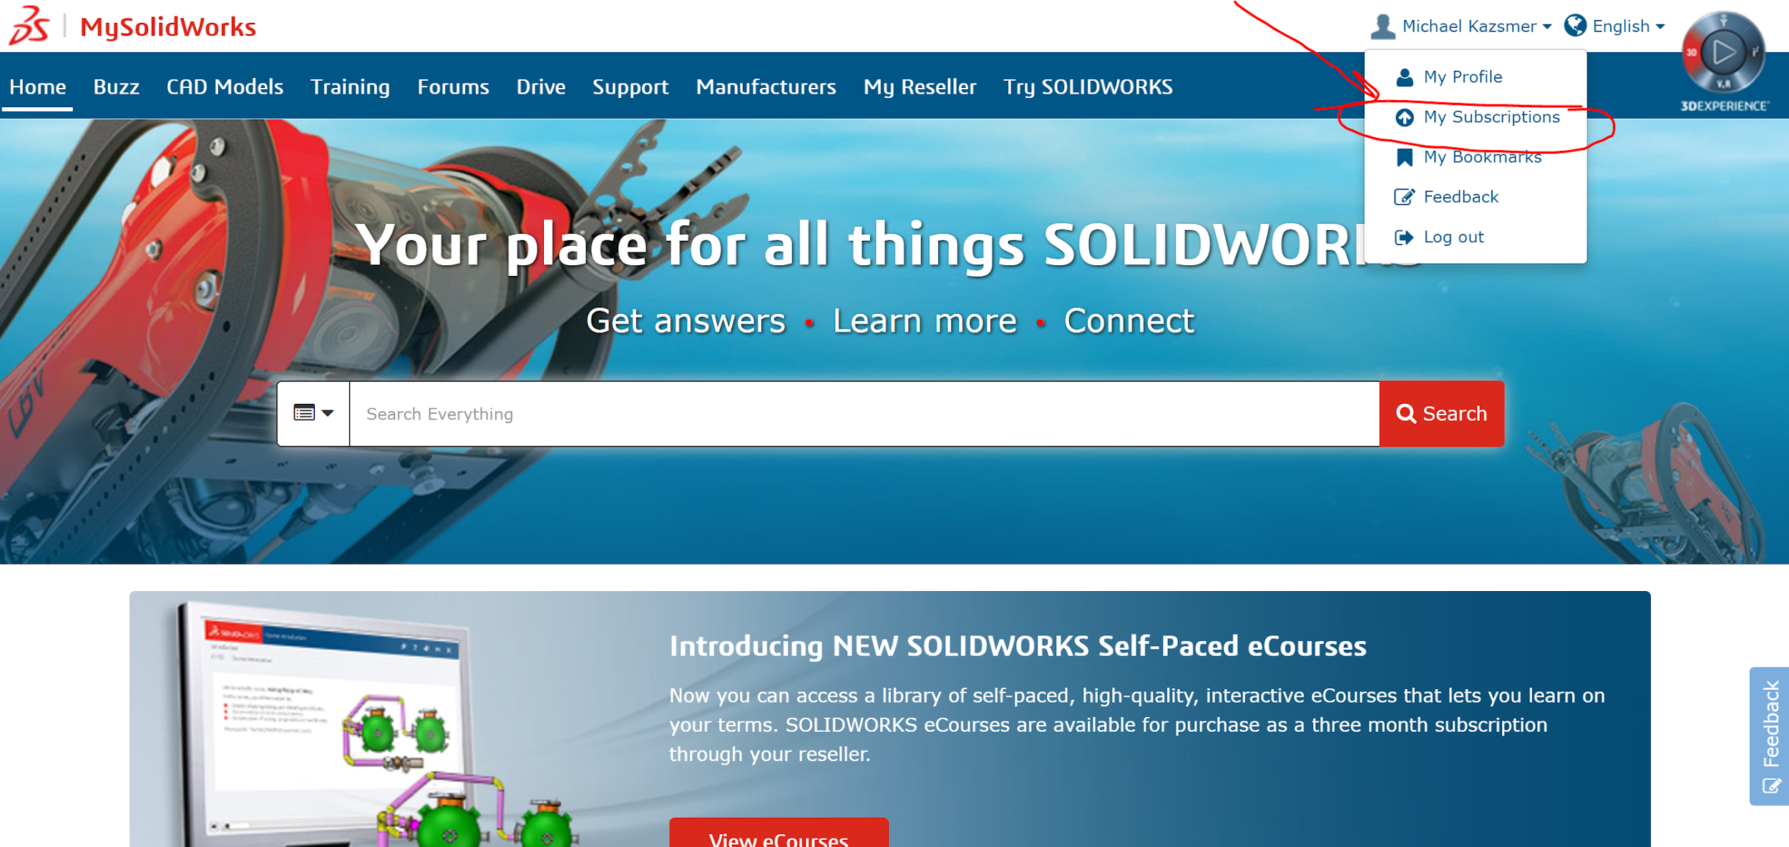
- Click “My SolidWorks for students” and type in the SEK number. Once the SEK is confirmed, you will have access to the CSWA prep course, along with hundreds of hours of additional training material. To get there, click “training” then “catalog”, check the box “standard”. This is everything you have access to with the standard license.
SEK# XSEK12TTA
- To get access to the CSWA prep, click the box “learning paths” and then scroll to “CSWA Exam Prep Course”. This is a learning path specifically to get students prepared for the CSWA exam.

- To easily get back to the CSWA prep course, click “add to my training”. Next time you log in, all you will need to do is click on the “training” tab and then click “my training”.

